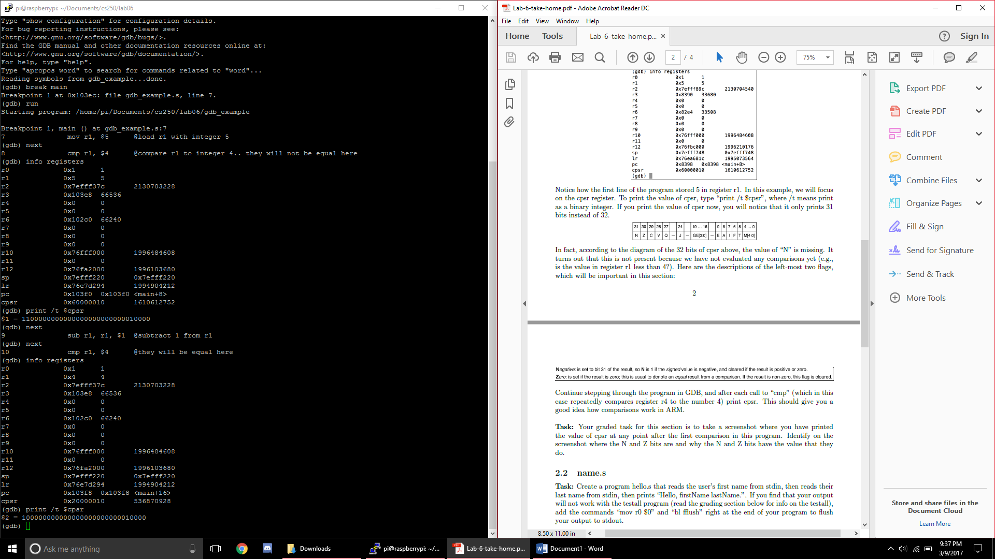I took the screenshot for the first compare after the first that was used as the example. The value for N is a 0 because the cmp does not have a negative number after the comparison. The value of Z is 1 because the computer deemed that what was being compared was equal. This is seen to have 31 bits because the N isn’t shown for the MSB.